

Fujitsu NZ Ltd

RCM_Import_GUI Tool

|  |
| --- |
| Document Details |
| **Version:**  1.0  **Version Date:** 19 July 2021  **Document Status:**  **Owner(s):** Fujitsu |

|  |  |  |
| --- | --- | --- |
| **Fujitsu New Zealand Limited** CN 37446 | | |
| Level 12, 141 The Terrace,  Wellington 6011  New Zealand | **Phone:** **Fax: Web:** | +64 4 495 0700  +64 4 495 0730  [www.nz.fujitsu.com](http://www.nz.fujitsu.com) |

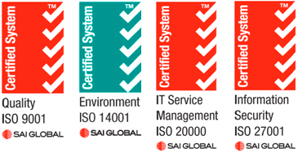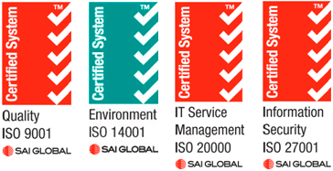

**Intellectual Property**

© 2017 Fujitsu New Zealand Limited. All rights reserved.

This material is authored by Fujitsu New Zealand Limited (Fujitsu). Fujitsu is the copyright holder of this material and provides the material to you for the purpose of the evaluation of the contents by you. Fujitsu does not authorise the use, reproduction, modification or adaptation of the material without Fujitsu’s prior written consent.

**Confidentiality**

This publication contains confidential and proprietary information and data. It is provided to you in confidence and on the express understanding that it shall neither be disclosed to any third party, nor used other than for evaluation purposes, without the prior written consent of Fujitsu.

**Disclaimer**

This material does not constitute an offer capable of acceptance and does not result in a binding contract between the parties. The supply of the goods and services referred to in this document will be subject to entry by Fujitsu and you into a formal agreement under the CC-ICT Agreement for purchase of Desktop as a Service.

While we have endeavored to ensure that the information contained in this document is correct and fairly stated at the time of writing, no liability is accepted for any error or omission.

Fujitsu reserves the right to make changes to this document and its contents at any time.

Table of Contents

Table of Contents 3

Requirements 3

CreateMST Description 3

Usage instructions 4

Requirements

* PowerShell version 3+

RCM_Import_GUI Description

The tool consists of the **RCM_Import_GUI.ps1** file, and the **RCM_Import_GUI.bat** file.

The bat file just launches the ps1 file

This script can import applications into SCCM

Usage instructions

The Tool looks something like this

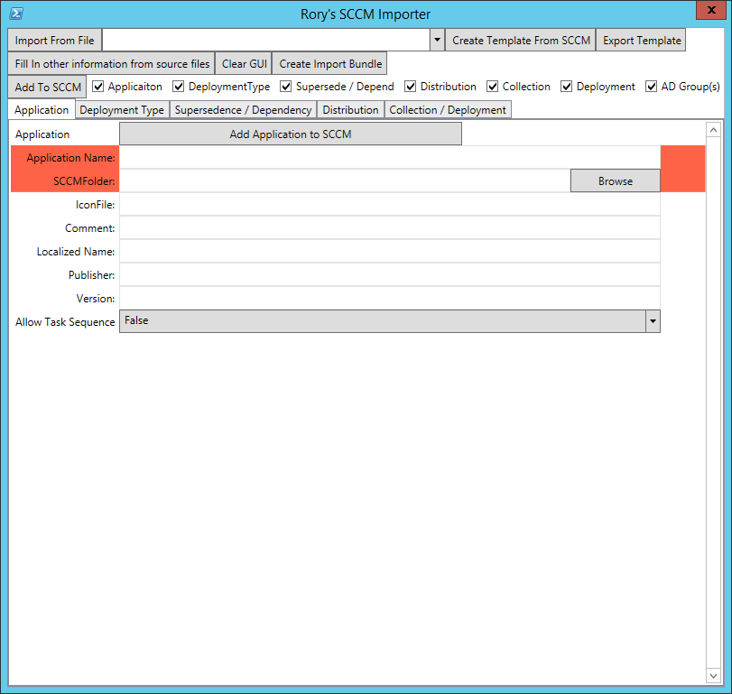

1. First copy settings from an existing application by selecting the application from the dropdown at the top and clicking “Create template from SCCM”. Ideally this will be a template application created for this purpose but it can be any application.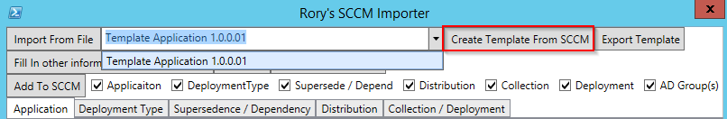
   * You can also import one from a file if you have created a file beforehand.
2. Click “Fill In other information from Source FIles” and select the Main install file (the script, msi or app-v) 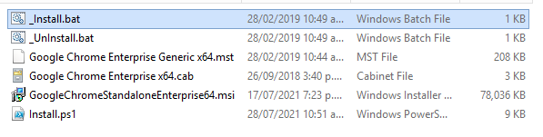
   * This will fill in most of the required information but you will want to check that the settings are correct
   * Msis and app-vs will have almost all nessassary information filled in but scripts will need more information added
3. Go through the following pages and check the settings

## Application

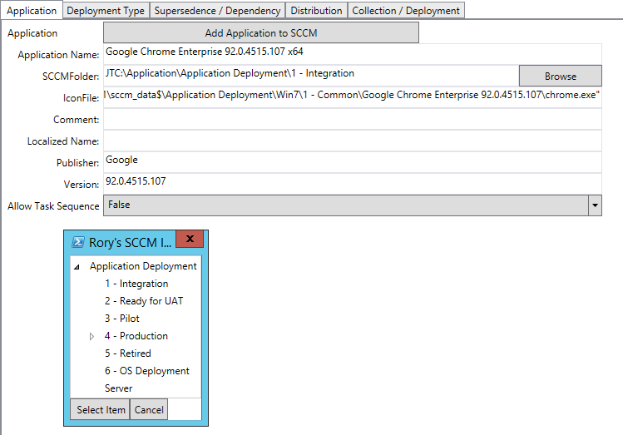

Everything here should be understandable to anyone familiar with SCCM

## Deployment Type

